Part Number: PT929-18170

Kit Contents

|  |  |  |
| --- | --- | --- |
| Item # | Quantity Reqd. | Description |
| 1 | 1 | Applique, RR Bumper |
| 2 |  |  |
| 3 |  |  |
|  |  |  |

Hardware Bag Contents

|  |  |  |
| --- | --- | --- |
| Item # | Quantity Reqd. | Description |
| 1 |  |  |
| 2 |  |  |
| 3 |  |  |
|  |  |  |

Additional Items Required For Installation

|  |  |  |
| --- | --- | --- |
| Item # | Quantity Reqd. | Description |
| 1 |  |  |
| 2 |  |  |
| 3 |  |  |
|  |  |  |

Conflicts

|  |
| --- |
|  |

Recommended Tools

|  |  |
| --- | --- |
| Personal & Vehicle Protection | Notes |
| None |  |
|  |  |
|  |  |
| Special Tools | Notes |
| Squeegee | 4" (3M™Gold) |
| Low Friction Sleeve | 3M SA-1 (**OPTIONAL**) |
| Surface Thermometer | Infrared Non-contact |
| Heat Gun | Master Heat Gun HG-301A or equivalent |
| Installation Tools | Notes |
| Lint Free Rags |  |
| Spray Bottle | For wetting agent |
|  |  |
| Special Chemicals | Notes |
| Cleaner | VDC approved cleaner and cleaning method |
| Wetting Agent  Note: Solution depends upon ambient temperature of the **part** and the **vehicle** **surface**. If it is difficult to remove bubbles with a squeegee, add one more ml of shampoo. | Johnson’s Baby Shampoo  mixed in one liter of water:  At 65˚F add 2 ml. shampoo  At 70˚F add 3 ml. shampoo At 80˚F add 3.5 ml shampoo  At 90˚F add 4 ml. shampoo |
|  |  |

General Applicability

|  |
| --- |
|  |

Recommended Sequence of Application

|  |  |
| --- | --- |
| Item # | Accessory |
| 1 |  |
| 2 |  |
| 3 |  |
|  |  |

\*Mandatory

Vehicle Service Parts (may be required for reassembly)

|  |  |  |
| --- | --- | --- |
| Item # | Quantity Reqd. | Description |
| 1 |  |  |
| 2 |  |  |
| 3 |  |  |
|  |  |  |

Legend

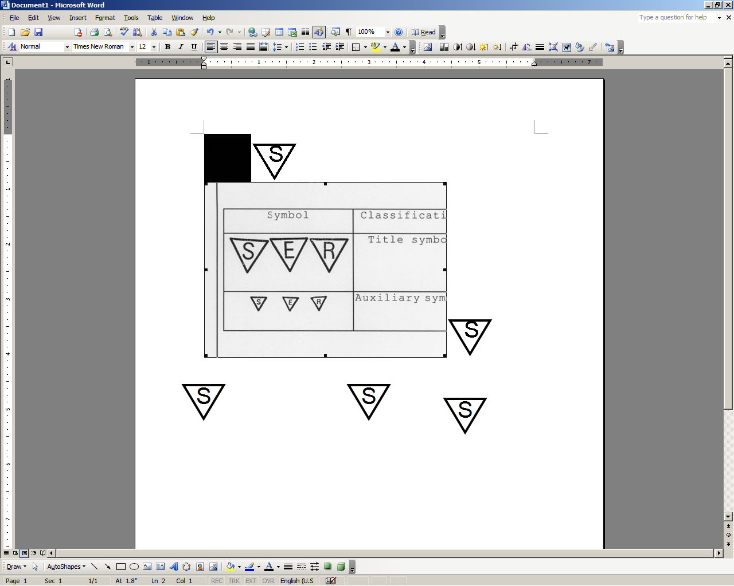

**STOP:** Damage to the vehicle may occur. Do not proceed until process has been complied with.

**OPERATOR SAFETY:** Use caution to avoid risk of injury.

**CAUTION:** A process that must be carefully observed in order to reduce the risk of damage to the accessory/vehicle and to ensure a quality installation.

**TOOLS & EQUIPMENT:** Used in Figures calls out the specific tools and equipment recommended for this process.

**REVISION MARK:** This mark highlights a change in installation with respect to previous issue.  
  
**SAFETY TORQUE:** This mark indicates that torque is related to safety.



Care must be taken when installing this accessory to ensure damage does not occur to the vehicle. The installation of this accessory should follow approved guidelines to ensure a quality installation.

These guidelines can be found in the "Accessory Installation Practices" document.

This document covers such items as:-

* Vehicle Protection (use of covers and blankets, cleaning chemicals, etc.).
* Safety (eye protection, rechecking torque procedure, etc.).
* Vehicle Disassembly/Reassembly (panel removal, part storage, etc.).
* Electrical Component Disassembly/Reassembly (battery disconnection, connector removal, etc.).

Please see your Toyota dealer for a copy of this document.

Prepare the Vehicle.

* 1. stop_2The part and the vehicle surface temperature must be maintained between 65°F and 90°F for optimum installation.
  2. Store the parts flat at room temperature in a clean, dry place.
  3. Place a protective blanket in the trunk area to protect it from overspray of the wetting agent.
  4. stop_2Clean the entire application surface to remove grease and wax. Clean the entire area with a VDC approved cleaner and cleaning method.
  5. Wipe the cleaned surface with a clean, dry, lint-free cloth.

##### Install the Rear Bumper Applique.

* 1. Place the part face down on a clean, flat surface. Remove entire liner (Fig. 2-1).

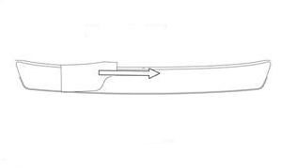

Fig. 2-1

Remove entire liner

(Part face down)

* 1. Spray the bumper with wetting agent (Fig. 2-2).

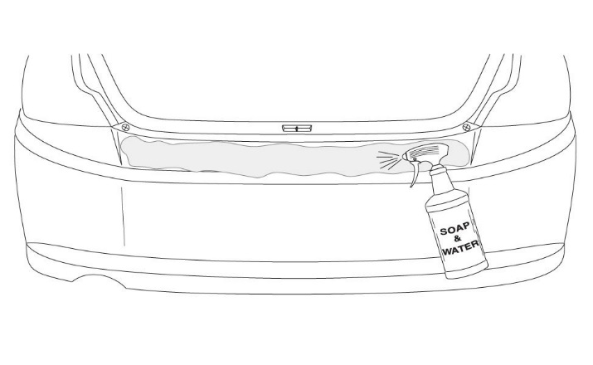

Fig. 2-2

* 1. stop_2Align the center notch directly below the striker latch opening and the leading edge of the premask along the vertical surface of the bumper (Fig. 2-3). Be sure not to roll the part onto the vertical surface.

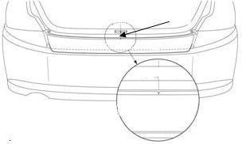

Fig. 2-3

Center notch to striker latch



caution_2**NOTE:** Do not smooth the part with hands.

* 1. Spray the premask with wetting agent. Use long, smooth, overlapping strokes with the squeegee from the center outwards of the horizontal section and begin to wrap the part over the bumper (Fig. 2-4).

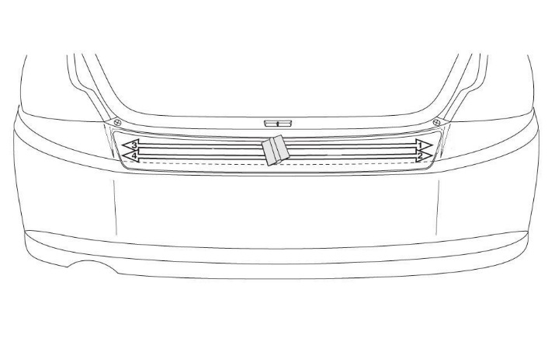

Fig. 2-4

Long, smooth, overlapping strokes

Squeegee



caution_2**NOTE:** Do not use excessive force as it may cause creasing of the protector.

* 1. Carefully remove the premask paper 180˚ against itself prior to squeegeeing the final wrap area (Fig. 2-5).

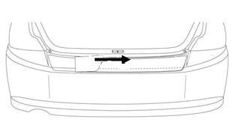

Fig. 2-5

Remove premask

* 1. Use the squeegee to make smooth, overlapping, downward strokes from the center outwards of the final wrap area on the vertical section (Fig. 2-6).

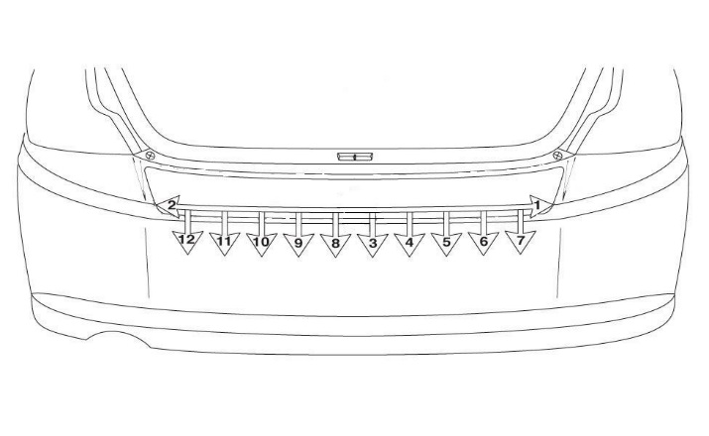

Fig. 2-6

Overlapping strokes

Squeegee



* 1. Dry off the vehicle with a clean, lint-free cloth.

Accessory Function Checks

Proper adhesion – visual

Proper adhesion – physical

Proper alignment – cross-car

Vehicle Function Checks

Bubbles; loose and lifting edges

With light pressure rub hand over top of part and if crackling sound occurs, re-squeegee. If bubbles cannot be worked out to the nearest edge, replace part.

Part must be centered within bumper +/-3 mm

Vehicle Appearance Check

After accessory installation and removal of protective cover(s), perform a visual inspection.

Ensure no damage (including scuffs and scratches) was caused during the installation process.

(For PPO installations, refer to TMS Accessory Quality Shipping Standard.)